Project Report
Title: Word Ladder Solver – Hacker UI Edition

1. Introduction
The Word Ladder Solver is a modern take on the classic word transformation puzzle, where players aim to transform a given start word into an end word by changing one letter at a time, ensuring all intermediate steps are valid English words.
This version is built as a lightweight frontend-only web application, emphasizing a hacker-style user interface for a fun, retro-terminal aesthetic. Unlike traditional games, this implementation functions as a solver tool rather than a challenge-based puzzle.
It leverages JavaScript's Breadth-First Search (BFS) algorithm to compute the shortest ladder path and offers a fast, responsive UI built with Tailwind CSS and plain JavaScript.

2. Objective
The goals of this project include:
- Developing a fully browser-based Word Ladder solver tool
- Enhancing user engagement through a stylized hacker terminal interface
- Reinforcing concepts of algorithmic problem solving through a clean UI
- Ensuring valid transformations using a real English word dictionary
- Providing quick feedback through a minimal and focused interface

3. Game Logic and Working
💡 Working Flow:
- The user inputs a valid start and end word (4 letters).
- The application checks if both words exist in the preloaded dictionary.
- A BFS algorithm finds the shortest path from start to end:
  - Only words differing by one letter are allowed per step.
- The result is printed on screen:
  - ✅ Ladder found: Displays the path (e.g., cold → cord → card → ward → warm)
  - ❌ No ladder found: Displays a failure message

📌 Example:
Start: cold
End: warm
Output:
>>> LADDER FOUND:
cold → cord → card → ward → warm

4. User Interface & Experience
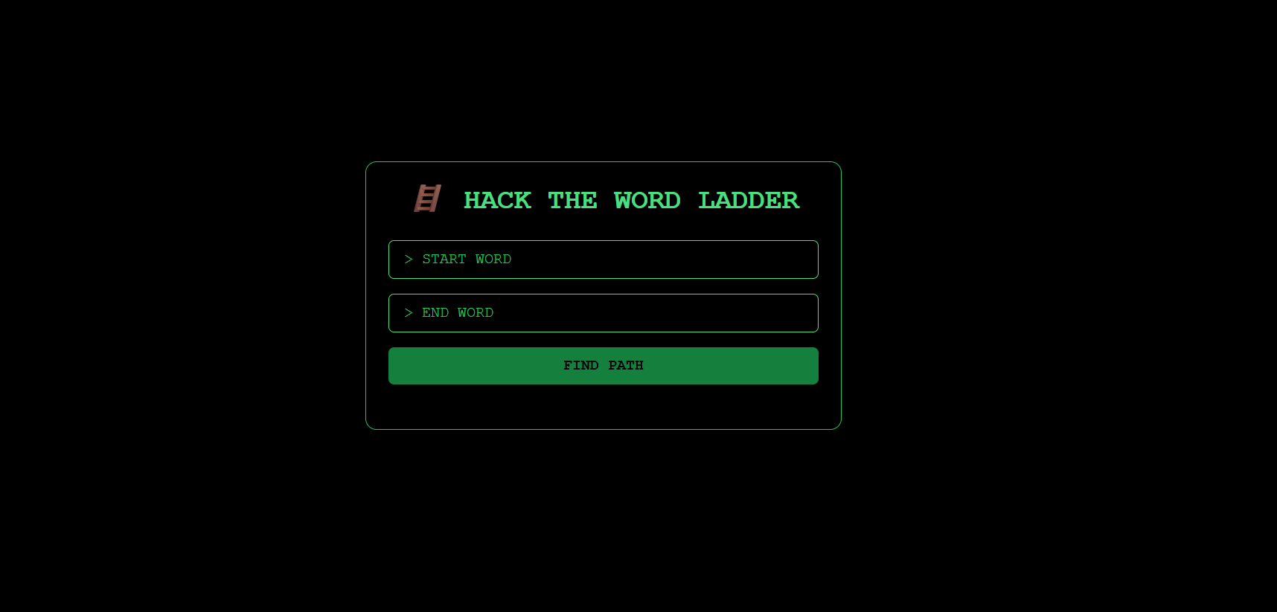
The UI uses a Hacker Terminal Theme, crafted with Tailwind CSS, featuring:
- Neon green monospace text on a black background
- Glowing button effects and selection highlighting
- Minimal input fields with placeholder prompts
- Clear output messages in terminal-style formatting
All components are designed to resemble a command-line interface, enhancing the immersive experience for users.

5. Key Features
- ✅ Shortest Path Solver using BFS
- ✅ Real English Dictionary loaded directly from a JS file
- ✅ One-Letter Change Validation
- ✅ Responsive Hacker UI with Tailwind styling
- ✅ Real-Time Output with success/failure feedback

6. Educational & Cognitive Benefits
This tool is not just functional but also educational, promoting:
- Algorithmic thinking (pathfinding with BFS)
- Vocabulary reinforcement (exposing word relationships)
- Pattern recognition (spotting valid transitions)
- UI design principles (theme-based styling using Tailwind)

7. Future Scope
Possible enhancements in the future:
- Add Strict Mode Puzzle: Only one specific path is accepted
- Generate random start/end word pairs
- Include hint system, timer, or leaderboard
- Add mobile touch support and PWA compatibility
- Introduce typing animations and sound effects for hacker vibes

8. Author & Repository
- Developed by: Sambhav Anand
- GitHub Repository:
- Technologies Used:
  - HTML
  - Tailwind CSS
  - JavaScript (Frontend-only)
  - Dictionary from Google 10000 English Words (4-letter filter)

